Your Special day in Camden
Choices Form - Marriage / Civil Partnership Ceremony Details

(Please delete as applicable)

Full name of couple to be united
Groom / Partner 1
(First Middle Surname)
Bride / Partner 2
(First Middle Surname)

*Your full names will be used to say the statutory declarations
What name do you prefer to be known by during your ceremony?
Groom / Partner 1
Bride / Partner 2

CEREMONY VENUE:
(Do not fill in this section if you are getting married in the Camden Town Hall)
Name of Venue AND Room
Have you booked the venue?
Have you received confirmation from the venue?
Name of the person who confirmed your booking
CEREMONY DETAILS:
Date and time of your ceremony | Day – Date – Month –Year  Time - HH: MM (Morning / Afternoon / Evening)
How many guests are you expecting?
Will you be making an ‘Entrance’? | Yes or No  If yes with whom? (Relationship and Name)
How would you like to be introduced to your guests at the end of your ceremony?

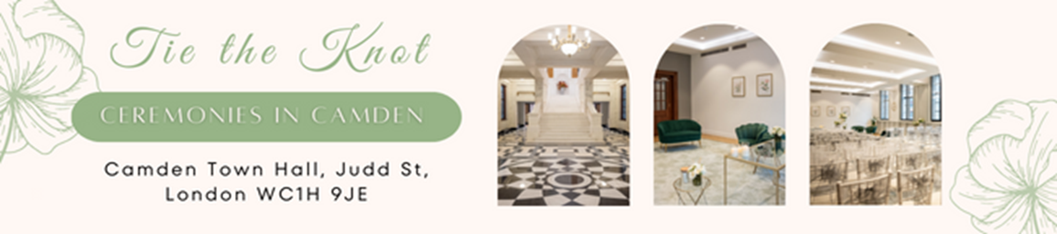

SCRIPT AND READINGS
(Circle or delete applicable and preference)
MARRIAGE SCRIPTS | CIVIL PARTNERSHIP SCRIPTS
- Traditional  - What is marriage?  - Will you?  - The purpose of marriage  - Own pre-approved script? | - Simple ceremony (No rings)  - What is civil partnership  - Will You?  - The purpose of a civil partnership
Will you be making amendments to the script? | Yes / No  (Have you added any personal non-religious vows?)
Your allocated registrar will need the final script from you before your ceremony

Will you be having any readings? | Yes / No  If so it must be non-religious and not taken from any religious script.
Please provide the name of your readings
Reading 1

Reading 2

MUSIC in the Town hall
Will you be providing music for your ceremony? | If Yes please have 4 sets of music for reasons below
If so the music must be non-religious (i.e. no hymns, chants or spiritual songs) and must not contain any religious script.
- As guests arrive
- Entrance of Party One or Couple
- During the signing of the register
- At the end of the ceremony to exit
Built-in Bluetooth and speakers available with Spotify in every room of the Town hall

RINGS
Will you be exchanging Rings? | Yes / No
If so how many are you using? | One / Two
Who will have the rings?  Name of Ring Bearer? | Relationship and Name
WITNESSES
Please provide the names of at least 2 people who will be acting as your witness
Witness 1 | (Only First Name & Last Name)
Witness 2 | (Only First Name & Last Name)

FATHER’S DETAILS
For historical purposes.
Adopted or step mother can be recorded as well – please speak to your allocated registrar.
Groom/Partner 1 - Father’s full name: | (First Middle Surname)
Is he still living? | Alive / Deceased
What is / was his last main occupation?
Is / was he retired?

Groom/Partner 1 – Father’s full name: | (First Middle Surname)
Is she still living? | Alive / Deceased
What is / was her last main occupation?
Is / was she retired?

MOTHER’S DETAILS
For historical purposes.
Adopted or step mother can be recorded as well – please speak to your allocated registrar.

Groom/Partner 1 – Mother’s full name: | (First Middle Surname)
Is she still living? | Alive / Deceased
What is / was her last main occupation?
Is / was she retired?

Bride/Partner 2 - Mother’s full name: | (First Middle Surname)
Is she still living? | Alive / Deceased
What is / was her last main occupation?
Is / was she retired?

IMPORTANT INFORMATION
We would kindly ask that you advise your guests that they do not throw confetti, foil, fresh or dried flowers when within the Town Hall.

